**CSA0562- DBMS**

- B. Rishitha

192324130

Student ddl query:

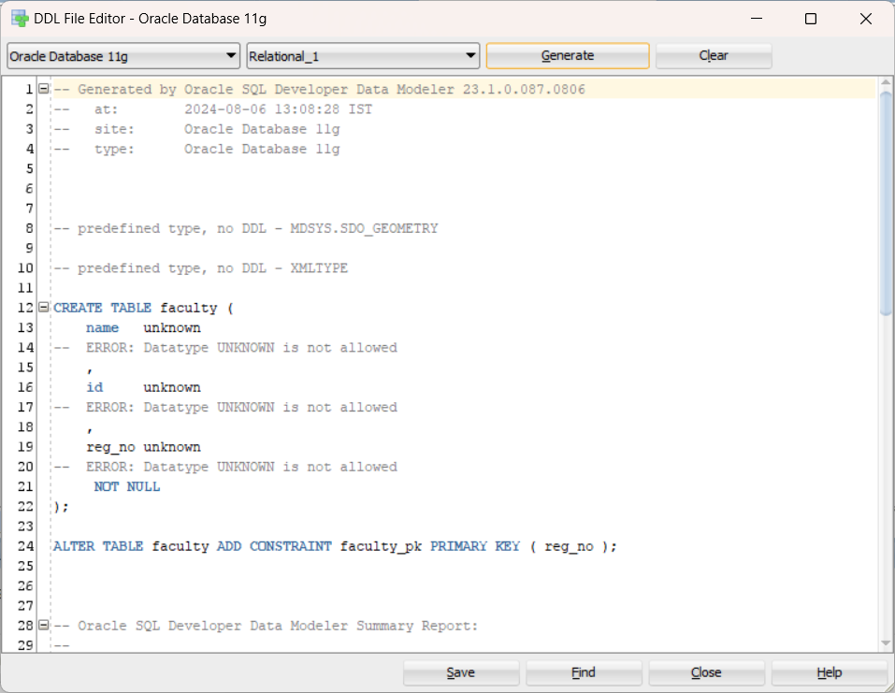

Course registration:

